**1) Create my site**

- create a new web app called “mySiteSp.kisp.com” using same membership & role as sp.kisp.com

- modify the managed path for mySiteSp.kisp.com to:

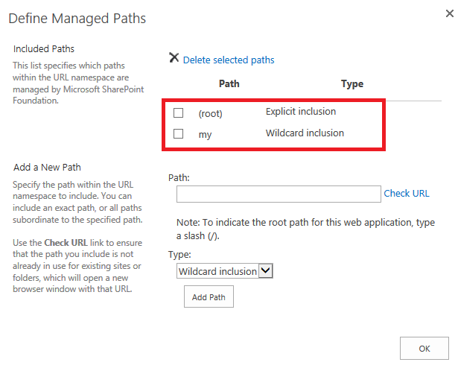

-create a site collection under root “/” using template Enterprise - My Site Host

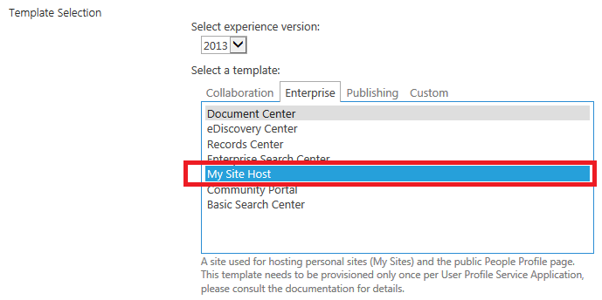

**2) Turn on Self-Service Site Creation**

- go to SharePoint 2010 Central Administration > [Application Management](http://evadne7:17076/applications.aspx) > [Manage web applications](http://evadne7:17076/_admin/WebApplicationList.aspx)

- highlight mySiteSp.kisp.com and click Self-Service Site Creation on ribbon

- turn on and click ok

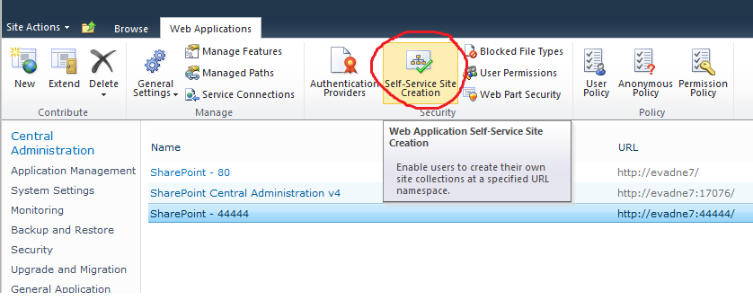

**3) Setup User Profile**

-Go to SP central admin > Application Management > Manage service applications

-If User Profile Service not exists then create new

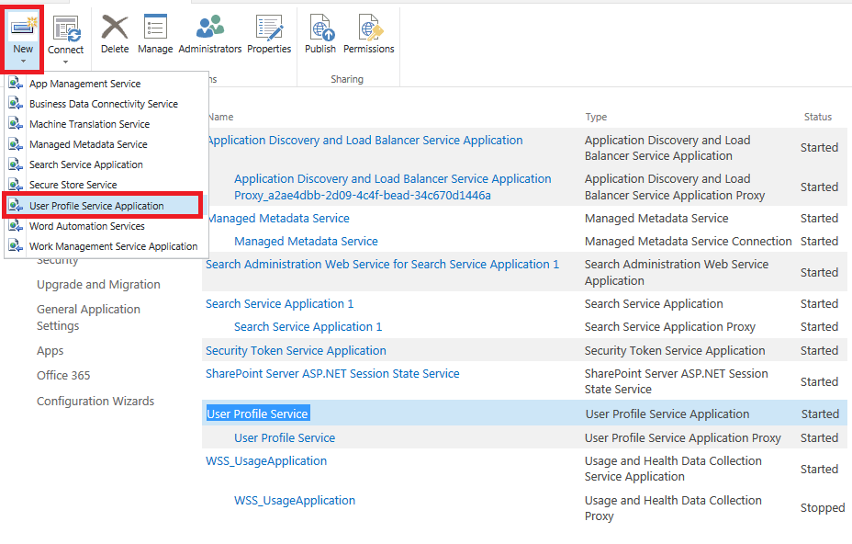

-fill any necessery info

My Site Host as: <http://mySiteSP.kisp.com/>

My Site Managed Path: /personal

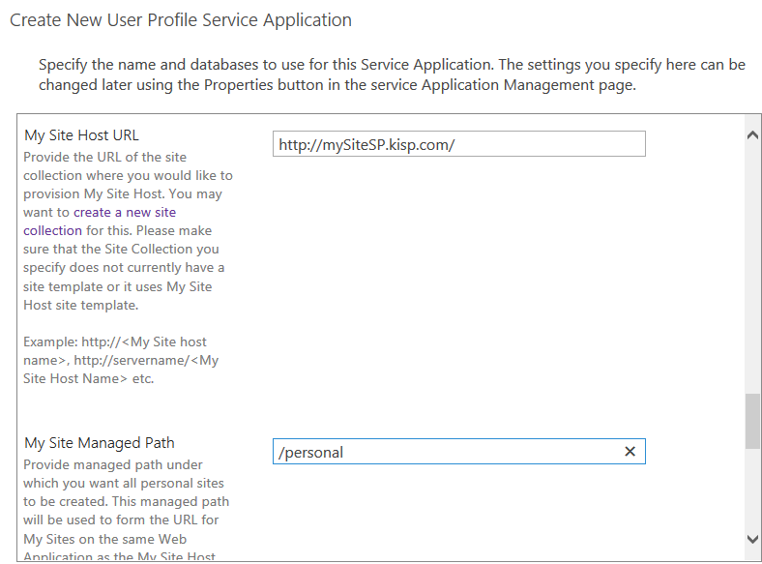

-once it is created make sure the service is running.

Central Admin > System Settings > Manage services on server

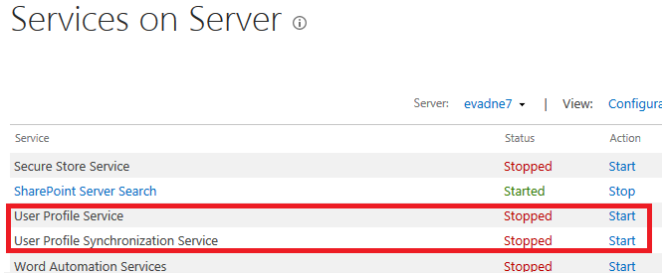

**4) setup Managed Metadata Service**

-Go to SP central admin > Application Management > Manage service applications

-If User Profile Service not exists then create new

-fill any necessery info: Content Type hub: (leave it empty)

-once it is created check if the service is running

Central Admin > System Settings > Manage services on server

